BREAKFAST MENU

Villa Luso Breakfast R40.00
2 x Eggs, 3 x bacon, tomato, chips & 1 x Toast

Russian Breakfast R35.00
1 x Russian, 2 x eggs, tomato & 1 x Toast

Vienna Breakfast R40.00
2 x Vienna, 2 x eggs, tomato, chips & 1 x Toast

Steak Breakfast R85.00
1 x 200g Rump, 2 x eggs, tomato, chips, mushrooms & 1 x Toast

Patti Breakfast R65.00
1 x 200g Patti, 2 x eggs, 2 x bacon, tomato & 1 x Toast

Ham Breakfast R45.00
2 x Eggs, 3 x ham, 2 x cheese, chips & 1 x Toast

Chorizo Breakfast R65.00
1 x 100g Chorizo, 2 x eggs, mushrooms, tomato, chips & 1 x Toast

Liver Breakfast R55.00
Chicken Livers, 2 x eggs, 2 x bacon, tomato, chips & 1 x Toast

Rump Breakfast R65.00
100g Rump steak, 2 x eggs, 2 x bacon, tomato, chips & 1 x Toast
Breakfast Beverages
Coffee R16.00
Tea – Five Roses/Rooibos R16.00
Milo/Hot Chocolate R20.00
Cappuccino R20.00
STARTERS

Calamari Rings & Chips R50.00
Deep fried

Buffalo Wings & Chips R50.00
4 Wings – Flame-grilled – made the Portuguese way

Prawn Starter – served with fresh bread R65.00
6 Prawns prepared in lemon & garlic butter and parsley

6 Creamy Garlic & Cheese Prawns R65.00 6 Prawns, Cleaned and prepared in a creamy garlic & cheese sauce

Chicken Livers R40.00
Served with soft bread

Crumbed Mushroom R50.00
Served with tartar sauce

Creamy Garlic Snails with Button Mushroom R60.00
Served with White/Brown soft Bread

Garlic Butter Snails R50.00
Served with White/Brown soft Bread

SALADS

Greek Salad – Feta & Olives + Peppadew R45.00
Chicken, Feta & Peppadew Salad R60.00
Prawn, Avocado & Peppadew Salad R65.00
Calamari, Bacon & Peppadew Salad R60.00
Calamari, Avocado & Peppadew Salad R65.00
Avocado & Peppadew Salad R60.00

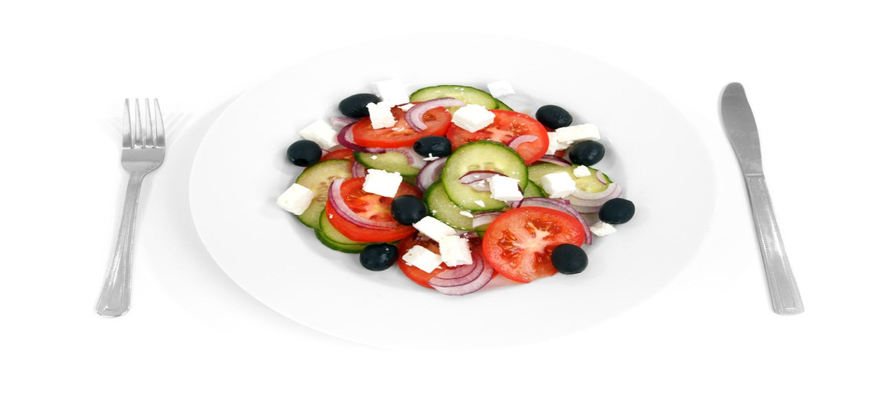

SEAFOOD
8 Prawns + Calamari R 145.00
8 Prawns R 125.00
Hake & Calamari R 95.00
Calamari Rings R 85.00
Hake & Chips + veg R 75.00

(Veg of the day – R20.00)

BURGERS
100g Pattie/Chicken Fillet – 200g
Beef Burger R40.00 R55.00
Chicken Burger R40.00 R55.00
Beef Cheese Burger R45.00 R60.00
Chicken Cheese Burger R45.00 R60.00
Beef, Bacon & Cheese Burger R50.00 R65.00
Chicken, Bacon & Cheese Burger R50.00 R65.00
Beef Dagwood Burger R55.00 R75.00
(Bacon, egg, ham & Cheese)
Chicken Dagwood Burger R55.00 R75.00
(Bacon, egg, ham & Cheese)

TOASTED SANDWICHES
(All Toasted Sandwiches are served with chips)
Ham & Cheese R45.00
Bacon & Cheese R50.00
Cheese & Tomato R35.00
Chicken Mayo R50.00

PREGO ROLLS
100g Fillet 200g Fillet
Beef Prego R60.00 R75.00
Beef & Cheese Prego R65.00 R80.00
Chicken Prego R50.00 R65.00
Chicken & Cheese Prego R55.00 R70.00

PIZZA’S
(Standard Tomato, Onion & oregano Base Sauce)

Russian, Vienna, Bacon & Ham R 95.00
Chicken & Mushroom R 70.00
Chicken & Pineapple R 75.00
Beef Fillet, Mushroom & Peppadew R 95.00
Avocado, Feta, Prawn & Bacon R100.00
Ham, Pineapple & Mushroom R 80.00
Russian, Ham, Chicken & Beef R100.00
Chicken Mayo Pizza R 90.00
Spare Rib Pizza R100.00
Sweet Chilli Chicken & Peppadew R 85.00
Vegetarian Pizza R 75.00
Olives, Mushroom, Feta, Peppadew, Tomato, Onion & Peppers

KIDDIES PIZZA’S
Bacon R45.00
Margarita R35.00
Hawaiian R45.00
Russian & Vienna R45.00

KIDDIES MEALS
200g Ribs & Chips R50.00
Crumbed Chicken Strips & Chips R40.00
3 Chicken Wings & Chips R40.00
Hake Strips & Chips R45.00

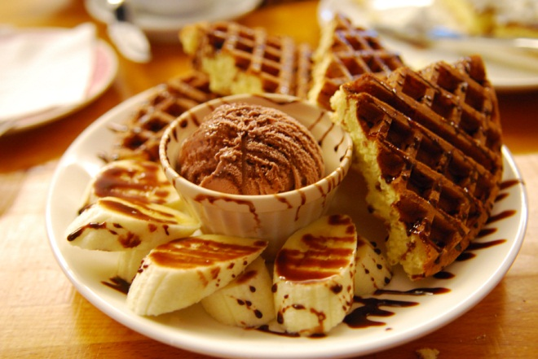
DESSERTS
Original Waffle –R25.00
(topped with ice cream and your choice of sauce chocolate sauce, honey, syrup)
Oreo Waffle – R35.00
(ice cream, Oreo Bits & chocolate sauce)
Berry bee Waffle – R40.00
(ice cream, Blueberries and honey)
Black cat Waffle – R40.00
(ice cream, Peanut butter and banana)
Kiddies Waffle – R20.00
(Quarter waffle with a scoop of ice cream, a cone, marshmallow and smarties)
Ice cream and chocolate sauce-R25.00
Don Pedro (Amarula/Kahlua/Frangelico) –R26.00
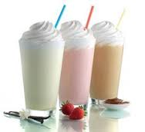
Irish Coffee – R30.00
Milkshakes
(All Milkshakes are R22.00)

*Milo *Vanilla *Chocolate
*Bubblegum *banana *Lime
*Coffee *Strawberry
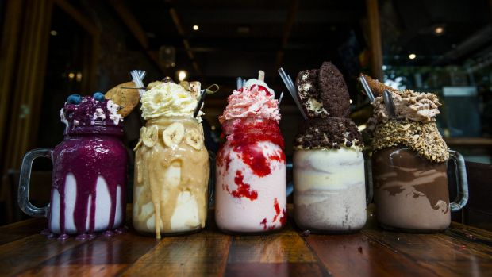
FREAK SHAKES!
(comes in a Jar, over flowing with flavours)
Strawberry marshmallow chunk – R30.00

Blueberry muffin – R32.50

Oreo freak shake- R28.00

Ginger and chocolate – R30.00

Peanut butter and banana – R32.50

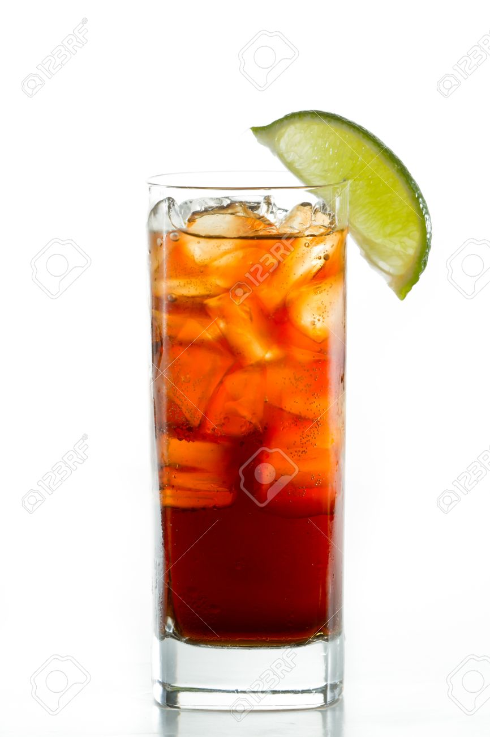
COCKTAILS
Litchi & Sours Twist R40.00
(White Rum, Litchi Juice & Apple Sours, garnished with a slice of lemon)
Purple Witch R40.00
(Cherry Sours, Lime, Berry Juice, Potency & Lemonade topped off with a
cherry)
Passionate Blue R40.00
(Cane, Passion fruit, Pineapple Juice & blue liquor, garnished with a slice of
lemon)
Strawberry Daiquiri R50.00
(Strawberry Liquor, White Rum, Berry Juice)
Cherry Cooler R45.00
(Grenadine, Cherry Liquor, White Rum & Berry Juice topped off with a
cherry)
Desert Storm R50.00
(White Rum, Strawberry Liquor, Grenadine, Orange Juice & Blue Liquor
topped off with a cherry)
Long Island Ice Tea R55.00
(Vodka, Tequila, Triple Sec, Bacardi, Gin, Lime & coke, garnished with a
slice of lemon)
Sex on the Beach R45.00
(Vodka, Grenadine, Berry Juice, Pineapple Juice topped off with a fresh
slice of Lemon)
Friends with Benefits R35.00
(Cherry Sours, Apple Sours, Vodka, Sprite, Butler Blue)
Blue Lagoon R40.00
(Butlers Blue, vodka, lemonade and garnished with lemons)
One night stand R50.00
(Peppermint, sours, lime, tequila, cane, coconut rum, peach schnapps,
Stroh rum & litchi juice)
Tequila Sunrise R50.00
(Tequila, orange juice and grenadine)
Mojito R35.00
(Mint leaves, white rum, triple sec & sprite)
Ocean Deep R55.00
(Vodka, Archer peach, Malibu, Butler Blue, Lime, Apple sours, Pineapple juice
with sprite topped off with a fresh slice of pineapple)

SHOOTERS

Sowetan Toilet R20.00
(Banana Liquor, Amarula & Nachtmusik)

Caramel Bears R20.00
(Caramel Vodka, Chocolate Vodka, Nachtmusik & Cream)

Mind Eraser R22.00
(Jagermeister, Tequila & Stroh Rum)

Springbokkie R20.00
(Peppermint Liquor & Amarula)

Briefcase R20.00
(Jack Daniels & Lime)

Turkish delight R18.00
(Grenadine, Nachtmusik & Cream)

Blow Job R18.00
(Kahlua, Amarula & Cream)

Big daddy bomb R28.00
(Potency, tequila & Stroh rum)

Bob Marley R28.00
(Grenadine, Banana liquor & peppermint)

Strawberry Bitch R20.00
(Strawberry liquor & peach schnapps)

Cactus jack Original or Bubble-gum R15.00

WINE LIST

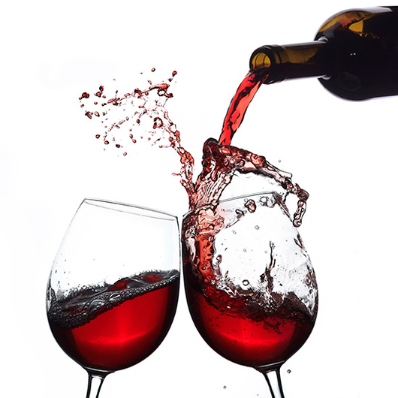
Graca White/Rose R60.00
Porcupine Ridge Sauvignon Blanc R85.00
Kanonkop Kadette R135.00
Nederburg Baronne R95.00
Kleine Zalze Merlot R150.00
KWV Sauvignon Blanc R95.00
Four Cousins Rose/Sweet White R80.00
Saint Claire Rose R50.00
Coffee Mocha Pinotage R130.00
Douglas Green Chenin Blanc R80.00
Fat Bastard Cabernet Sauvignon R220.00

MAINS
(All mains are served with 1 starch only)
200g Beef Fillet R 100.00
200g Rump Steak R 95.00
300g Rump Steak R 110.00
350g T-Bone R 100.00
500g T-Bone R 120.00
Buffalo wings – 8 wings R 85.00
Eisbein R 120.00
400g Ribs R 110.00
600g Ribs R 135.00
200g Chicken Schnitzel with any sauce & veg R 85.00
200g Beef Schnitzel with any sauce & veg R 100.00
Half Baby Chicken R 45.00
Full Baby Chicken R 75.00
Rib & Wing Basket R 85.00
200g Rump & Calamari R 110.00
Half Baby Chicken & Calamari R 80.00

SAUCES
Pepper R20.00
Garlic R20.00
Mushroom R20.00
Cheese R20.00
Garlic Butter R20.00

