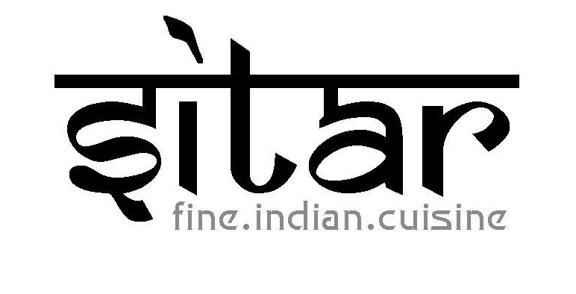
SET MENU: R350 PP

STARTERS:
- TANDOORI LAMB CHOPS (2 Lamb Chops marinated with yoghurt and spices and cooked in the Tandoori Oven)
AND
- PANEER TIKKA (Indian cottage cheese, green pepper, onion, tomato combined with delicious spices and grilled in the tandoori oven

MAINS: (ALL MAIN DISHES ARE SERVED WITH BASMATI RICE AND PLAIN NAAN BREAD AND SAMBALS)
Choice of one of the following
- CHICKEN KORMA (Boneless, tender chicken fillet cooked in a cashew nut and yoghurt gravy with butter)
- LAMB BIRYANI (Boneless pieces of lamb cooked with basmati rice and spices)
- VEGETABLE BIRYANI (Mixed vegetables cooked with basmati rice and spices). Served with a side order of yellow dhall
- ALOO MATTAR GOBI (Potatoes cooked with green peas and cauliflower in a delicious onion and tomato gravy). Served with a side order of yellow dhall
- FISH CURRY (Kingklip cooked in a tomato and onion gravy with coriander and curry leaves)
- PRAWN CURRY (Prawns cooked in a rich tomato and onion gravy)

DESSERTS: Choice of one of the following
- Vanilla Ice cream served with hot chocolate sauce
- Coconut Ice cream served with hot chocolate sauce
- Mango Gateau (Mango blended into an ice cream and coated in chocolate)
- Gulab Jamun (Soft milk dumplings drenched in syrup and served with vanilla ice cream)

