Neil’s Nosh - changes with the seasons, according to available local produce & Neil’s whims

Whipped smoked tuna, aubergine, tomato & preserved lemon 60

Salad of mixed leaves, dukkah labne, pickled carrot & orange dressing 65

Smoked chicken & butterbean broth 65

Sweet potato red curry, deep fried calamari 70

West coast mussels, Café de Paris butter 70

Charcuterie board, potato salad, lettuce & onion 75

Oxtail ravioli, bone marrow & brioche crumb 85

Walter’s ham, buffalo ridge mozzarella & tomato 85

White onion pizza, pepperoni & garlic confit 95

Risotto of pine kernel, celery & gorgonzola 110

Twice cooked eisbein, polenta & pickled quince 160

Butter roasted line fish, prawn mousseline & tomato dressing 170

Two day cooked Lamb neck, aubergine, tomato & garlic 180

Afrikaner beef rump, mascarpone gnocchi & roasted beetroot 195

Dry aged kudu chop, millet, date puree & kale 195

Sides – go on, add on…

Marinated olives 50

Sugar snaps, lemon oil & olive crumb 45

Gratin dauphinoise 40

Chips 20

Petit herb salad 15

lazy lunches . . . weddings . . . private dinners

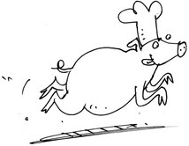

Petit à la carte - created by our kids for your kids...

Pizza toasts – mozzarella & tomato/salami/ham 25/50

Kids’ fish & chips 50

Fresh noodles & meat sauce 50

Pic ‘n mix board – cheese, fruit, ham, salami 45

Oakland’s pear juice 22

Hot chocolate 18

Fruit cordial – orangeade 18

One scoop ice cream/ sorbet 10

Vanilla bean, Chocolate, Tonka bean

Orange

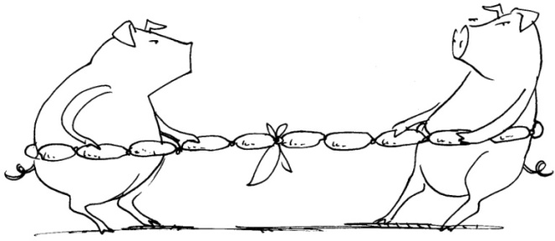

Neil’s Nom Noms - you just can’t say no!

Chocolate truffle trio, coffee 45

Plate of sweets –pecan brittle, nougat, nut toffee,

chocolate fudge, macaroon & marshmallow 45

Warm chocolate fondant, hazelnut ice-cream (please allow 15 minutes) 60

Spiced pumpkin soufflé, bay leaf ice-cream (please allow 20 minutes) 65

Cheese board – caraway wafers, chutney, sesame cheese balls 95

Bread & Wines Vineyard restaurant
breadandwineFH

www.breadandwines.co.za

www.moreson.co.za

