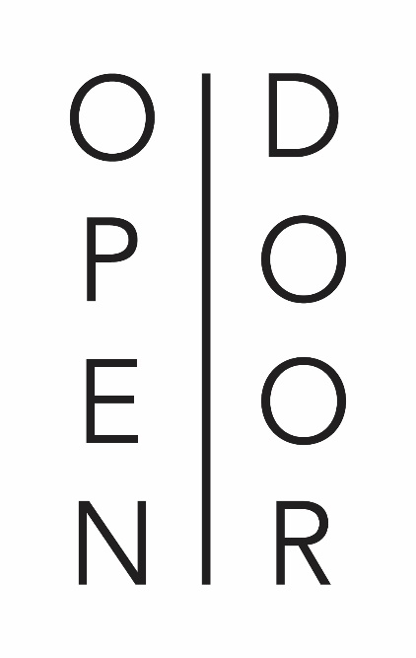

Open Door
Constantia Uitsig Wine Estate
www.opendoorrestaurant.co.za
+27-21-794-3010

How We Opened Our Doors
Dating back to 1685 when the farm named Constantia was granted to Simon van der Stel, the distinctive history of Constantia Uitsig has helped shape what Open Door restaurant is today.
Following its 17th century beginnings, during several generations of ownership by the Lategan family the land was divided up and a modest school opened its doors on the property in 1902. Known as Tokai Primary School, the original schoolhouse was replaced in 1917 by the building where you now sit, built by the Colonial Government to educate the children of warders at Porter Reformatory and Pollsmoor Prison.
Tokai Primary closed down in 1987 and the property sat unused until 2001 when it was privately sold and renamed Constantia Uitsig (uitsig means view in Afrikaans). At this point the schoolhouse was converted into a wine tasting room and restaurant, The River Cafe, which operated until 2014 when the property was sold to the current owners and the schoolhouse finally reincarnated into Open Door restaurant.

A la carte Menu

(Lunch served from 12h00 until 15h00 & Dinner served from 18h00 until 21h30)

Starters
Tuna R85
togorashi and soy seared tuna, English mustard mayonnaise and curry vinaigrette

Cured Salmon R110
cardamom and carrot, pickled carrots, duck fat crumble with tarragon vinegar jellies

West Coast Mussels R110
prosciutto broth, ginger and garlic, guanciale and toasted sourdough

Grilled Calamari R75
miso caramel, tomato concasse, homemade mayonnaise and roasted peanuts

Sirloin Tartare R90
soft spiced sriracha scotch egg with black pepper paste

Duck and Shiitake Terrine R85
almond and apricot chutney

Southern Fried Quail R79
sweetcorn and mint yoghurt salad with an Indonesian glaze

Saffron Poached Pear Salad R80
toasted walnuts, gorgonzola with honey mustard dressing

Chicken Caesar Salad R65/R85
cos lettuce, parmesan and croutons

Cauliflower Cheese R75
cauliflower and parmesan polenta ball, roasted cauliflower spuma, pickled cauliflower and pine nut dressing

Pepe Buchette Goats Cheese R85
salt roasted beetroot, honey and cumin lime dressing and toasted pecan nuts

Main course
White Onion Risotto R105
textures of onion, leek ash and crème fraiche

Gnocchi R110
beetroot gnocchi, ricotta, mushrooms, seed granola and liquorice puree

Linefish R180
crushed dill vinegar potatoes, cauliflower puree, chilli, lime and saffron mussels

Seared Norwegian Salmon R210
tabbouleh salad, roasted aubergine and a pine nut gel

Spicy White Fish & Prawn Laksa R165
soba noodles, wilted pak choi

BBQ Pork Belly & Cheek R170
parma ham, cabbage hash and cranberry jus

Waygu Beef Burger R155
streaky bacon, white cheddar and hand-cut chips

Rib Eye R220
crispy potatoes with sour cream and chives, grilled butter lettuce and chimichurri sauce

Chalmar Beef Sirloin R195
hand-cut chips, rocket and parmesan salad with a café de paris butter

Lamb Tortellini R150
feta baba ganoush, harissa paste and dukkah

DESSERT
Cream Cheese Strawberry R85
cream cheese mousse on chocolate short crust with strawberry jelly and dark chocolate liquorice sorbet

Panna Cotta R75
thyme panna cotta, pear and rooibos compote, vanilla sablé and orange mascarpone

Almond Frangipane R92
crispy milk chocolate layer, cinnamon whipped ganache and blueberry sorbet

Coffee Parfait R85
passionfruit curd, crushed ginger biscuit, brown butter sponge and Kahlua jellies

Peanut Butter R85
peanut butter mousse on vanilla sponge, lime pastilles, peanut butter caramel, coconut sorbet
and muscovado ice cream
Four Course Food & Wine Pairing Menu

(Please note that this menu is to be enjoyed by the entire table)

R685 incl. wine

First Course

Cauliflower Cheese
cauliflower and parmesan polenta ball, roasted cauliflower spuma, pickled cauliflower and pine nut dressing
~
Constantia Uitsig, Sauvignon Blanc, Constantia 2015

Second Course

Tuna
togorashi and soy seared tuna, English mustard mayonnaise and curry vinaigrette
~
Protea Rosé, Coastal Region 2016

OR

Southern Fried Quail
sweetcorn and mint yoghurt salad with an Indonesian glaze
~
Joostenberg, Chenin Blanc, Paarl 2016

Third Course

BBQ Pork Belly & Cheek
parma ham, cabbage hash and cranberry jus
~
Diemersdal, Pinotage, Durbanville 2015

OR

Linefish
crushed dill vinegar potatoes, cauliflower puree, chilli, lime and saffron mussels
~
InCahoots, Chardonnay, Western Cape 2015

Fourth Course

Panna Cotta
thyme panna cotta, pear and rooibos compote, vanilla sablé and orange mascarpone
~
Constantia Uitsig, Red Muscat, Constantia NV

CHILDREN’S MENU

(Served from 12h00 until 15h00 & Under 12 Yrs Only)

Spaghetti R65
Pea, bacon and parmesan

Hake R75
Pan roasted, butternut fingers and cucumber

Crispy fried Chicken R80
Crumbed nuggets with hand-cut chips

Toasted Sandwich R60
White cheddar, tomato with chips

Ice Lolly R25

Home-made Vanilla Ice Cream
& Chocolate Sauce R40

Cookies & Chocolate Milk R35

