DROSTDY RESTAURANT

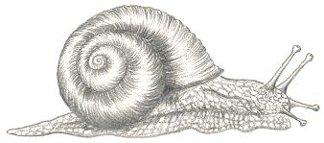

ENTREES

Freshly prepared Soup of the Day
And Ciabatta bread (V)
55

Double baked Aged Cheddar & Blue cheese Soufflé
Mustard, Apple & Celery Salad, Basil Pesto (V)
65

Smooth Chicken Liver Parfait, Red wine jelly,
Health bread and Caramelized Onions Marmalade
58

Thai style sautéed Calamari
Egg Noodles, Roasted Peanuts and fresh Herbs Salad
65

Smoked Rainbow Trout served on
Avocado, Red Onions & Sunflowers Seeds Salad
With Marie Rose dressing
85

Creamy Garlic & Parsley Snails
Served with fresh Ciabatta Bread
65
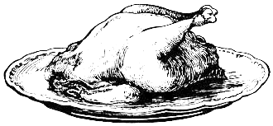
PLAT DE RESISTANCE

Classic style Fillet of Beef
Served with Crushed Baby Potatoes, Green Beans & Bacon parcel, Red Wine Sauce and Roasted Red Onions
190

Pan-fried Kingklip
With Crayfish Ravioli, Butternuts Puree, Wilted Greens, Chives and Kingklip Crème
195

Traditional Beef Bobotie, Turmeric scented Rice,
Roasted Vegetables, Banana Yogurt & Homemade Chutney
130

Trio of Game – Springbok, Impala and Ostrich
Roasted Vegetables, Cauliflower Puree,
Roasted Red Onions and Blueberries Jus
220

200g Beef Fillet
Golden French fries, mixed Garden Salad
Choice of Creamy Grain Mustard sauce Or Red Wine Jus
185

Chicken Ballotine
With Fricassee of Gnocchi, Garden Peas, Porcini Mushrooms, Grilled Cherry Tomatoes and Thyme Jus
145

Cherry Tomatoes & Basil Risotto with Avocado Salad Balsamic Reduction and Basil Pesto (V) 120
* With Kingklip Fillet 165

Seasonal Vegetables Bobotie,
Served with Traditional Accompaniments (V)
115
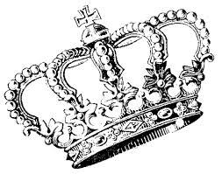 DESSERTS SELECTION

Warm Traditional Malva Pudding and Vanilla Ice Cream
48

Dark Chocolate and Toasted Hazelnuts Brownie,
Vanilla Ice Cream and Orange Coulis
55

Rooibos and Lavender Crème Brûlée
Served with a Cinnamon Arlette Biscuit
55

“Wildebraam” Berries Pannacotta
With Passionfruit Coulis
52

“Signature” Dessert Trio
*Malva Pudding
*Chocolate & Hazelnuts Brownie
*Local Berries Panna cotta
75

South African Cheese Selection
Homemade Preserves and Crackers
70
*Served with a Glass of Vintage Port – 95

Americano 20
Café Latte 24
Cappuccino 22
Espresso 18/24
Rich Hot Chocolate 28
Jameson’s Irish Coffee 60
Amarula/Frangelico Coffee 55
Earl Grey, Green tea, Camomile, Mint tea, Chai tea – 18

