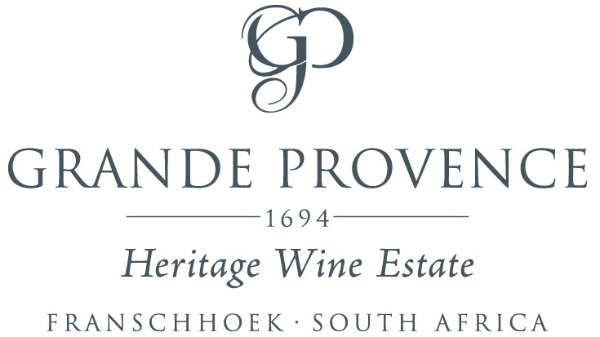

The Lunch Menu



**Welcome to the award-winning Grande Provence Restaurant**

Please note, our lunch à la carte menu is structured as a

Three course experience.

Please advise us one course in advance, should you like to have a break between courses.

3 – Course structured Lunch – R450.00

Saldanha Oysters, Mignonette Vinaigrette, Shucked on Request

**R90 for 3**

**Winemaker suggests – The Grande Provence Brut R130 per glass**

**Starters**

Gin cured Franschhoek trout, sweet & sour cucumber, dill crème, grapefruit

***Winemaker suggests – Grande Provence Sauvignon Blanc R50 per glass***

Heirloom Beetroot, chevin, walnut, honey

***Winemaker suggests – Grande Provence Rosè R50 per glass***

Cold roast beef sirloin, pinenut, mustard, daube kromeski, Boland cheddar, shallot

***Winemaker suggests – Grande Provence Shiraz R75 per glass***

Charred yellowfin tuna, miso, labneh, black garlic, dukkah, cauliflower

***Winemaker suggests – Grande Provence Zinfandel R75 per glass***

Hot & cold poke – langoustine, tempura baby vegetables, pickled daikon, wasabi

***Winemaker suggests – Grande Provence Brut Rose NV R75 per glass***



**Mains**

Pork & carrot - belly, crackling, kromeski, carrot textures, masala

***Winemaker suggests – Grande Provence Wooded Sauvignon Blanc R75 per glass***

Karoo lamb – neck, sweetbread, heirloom tomato, olive, pan jus, aubergine

***Winemaker suggests – Grande Provence Cabernet Sauvignon R75 per glass***

Cauliflower & mushroom risotto – herb butter, brie, pumpkin seed (V)

**Winemaker suggests – Grande Provence Chardonnay R75 per glass**

Beef, potato & gravy - beef fillet, tongue two ways, baby onion, gratin, spinach

**Winemaker suggests – The Grande Provence Red R150 per glass**

Local line fish – butter-poached mussels, gnocchi, lemon, kohlrabi

**Winemaker suggests – The Grande Provence White R120 per glass**

**Sides**

Polenta cake, baby leaf salad, spicy mayonnaise – R45

Roasted broccoli, Franschhoek olive oil, feta, rocket – R45

**Desserts**

70% Valrhona Fondant, peanut ice cream, apricot, sesame

Mango & hazelnut- micro sponge, lemon crumble, mango elements, cocoa bean namelaka

Summer berry pavlova- plum, milk, vanilla bean

***Winemaker suggests – L’Ormarins LBV Port R45 per glass with desserts***

Local artisanal cheeses, preserves, crispies, fruit & nuts

***Winemaker suggests – The Grande Provence Amphora R160 per glass***

***Grande Provence uses fresh and sustainably sourced fish***

***Please note that our menu is subject to change and availability***