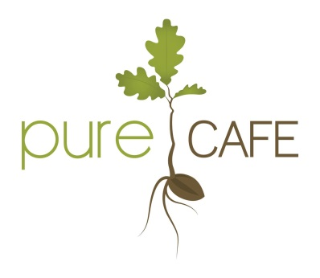
M E N U
Where possible we source seasonally available ingredients. Please check our blackboard for daily specials.

B R E A K F A S T M E N U
Sweetcorn fritters served with mushrooms and sweet chilli sauce R70
Chickpea omelette with mushrooms, spinach, tomato and vegan cheese R85
Gluten free flap jacks with cinnamon sugar, maple syrup, coconut cream, macadamia butter R60
Grilled tomato, sausage, mushrooms and baked beans on toast R75
Avo, mushrooms and hummus on sour dough bread R75

L U N C H M E N U
Soup of the day R45
Curry or stew of the day R85
Asian Bento Box (springrolls, dumplings, dim sum and raw rice paper wrap) R85
Pasta with olive, capers, tomato R75
Beyond Burger served on a roll with hummus, pesto, vegan cheese, mushroom, tomato with a side of chips R95

B A K E R Y please ask your waitress what is available….
Apple pie with coconut cream R35
Muffins R15
Chocolate fudge brownies R15
Carrot cake R35
Peanut butter balls R8
D R I N K S M E N U

Cool Stuff
Pure Coconut Water R24
Kombucha R30
Iced coffee R25
Aloe Vera R24
Water still R21
Water sparkling R23

Smooth Stuff
Mixed berry smoothie R45
(berries, banana, plant milk, dates)

Protein smoothie R45
(banana, peanut butter, raw cocoa, chia seeds)

Hot Stuff

Americano R20

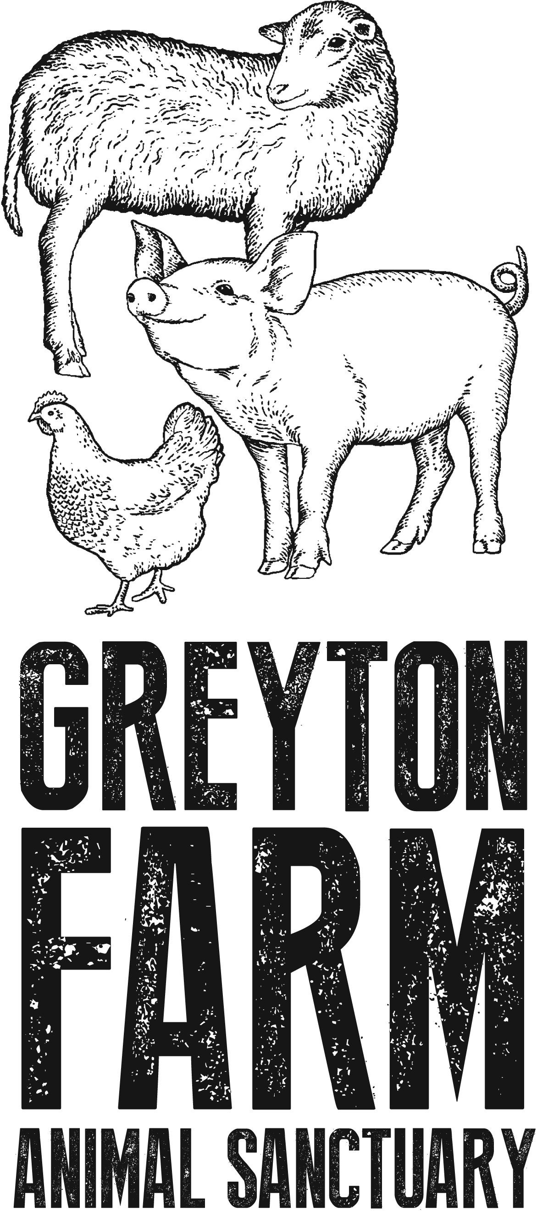
Flat White single R24 double R26

Cappucino small R22 large R28

Red cappuccino small R24 large R28

Rooibos, Earl Grey Tea R15

Green Tea, Honeybush Tea R18

Pure Café supports Greyton Farm Animal Sanctuary

