ROOYKLIPHOEK – 54 St Augustine Road, Paternoster Telephone: 0609773550 Open Daily from 8h00

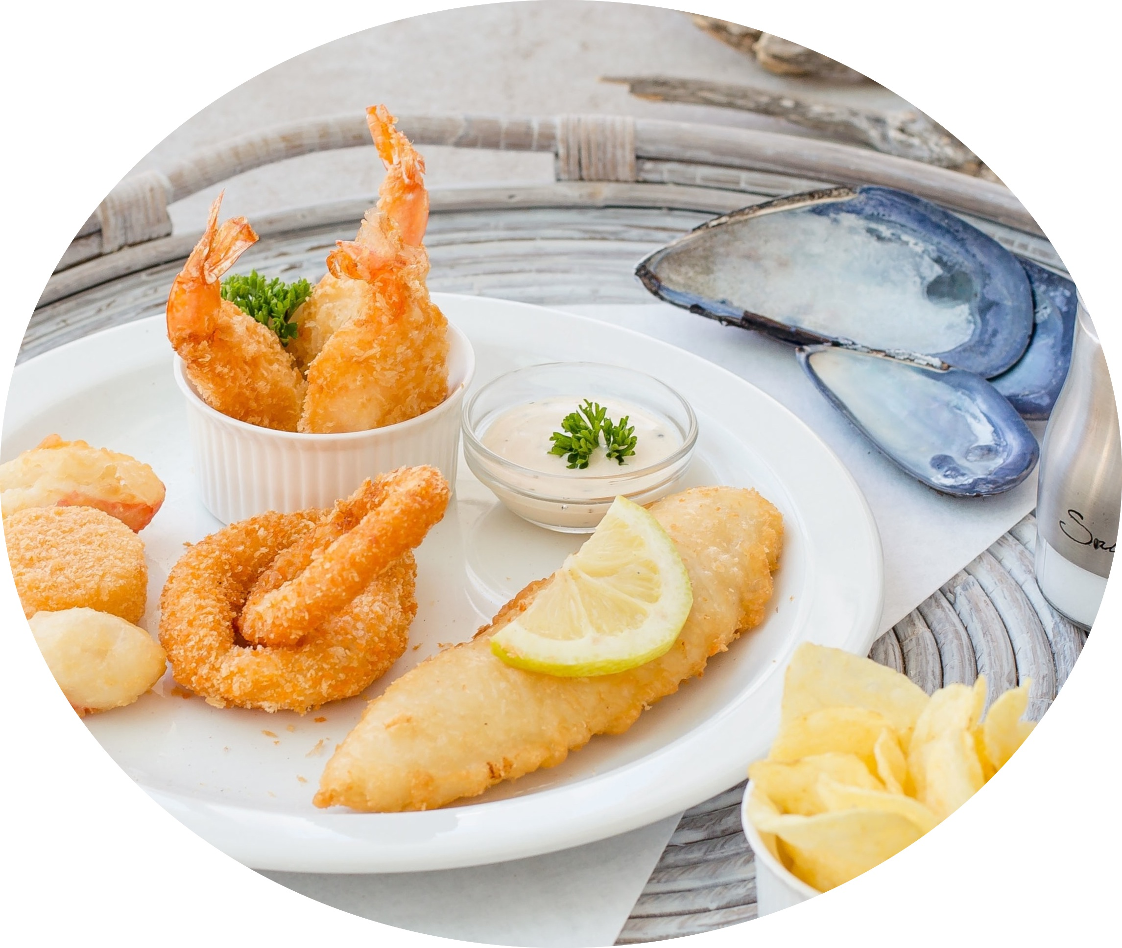 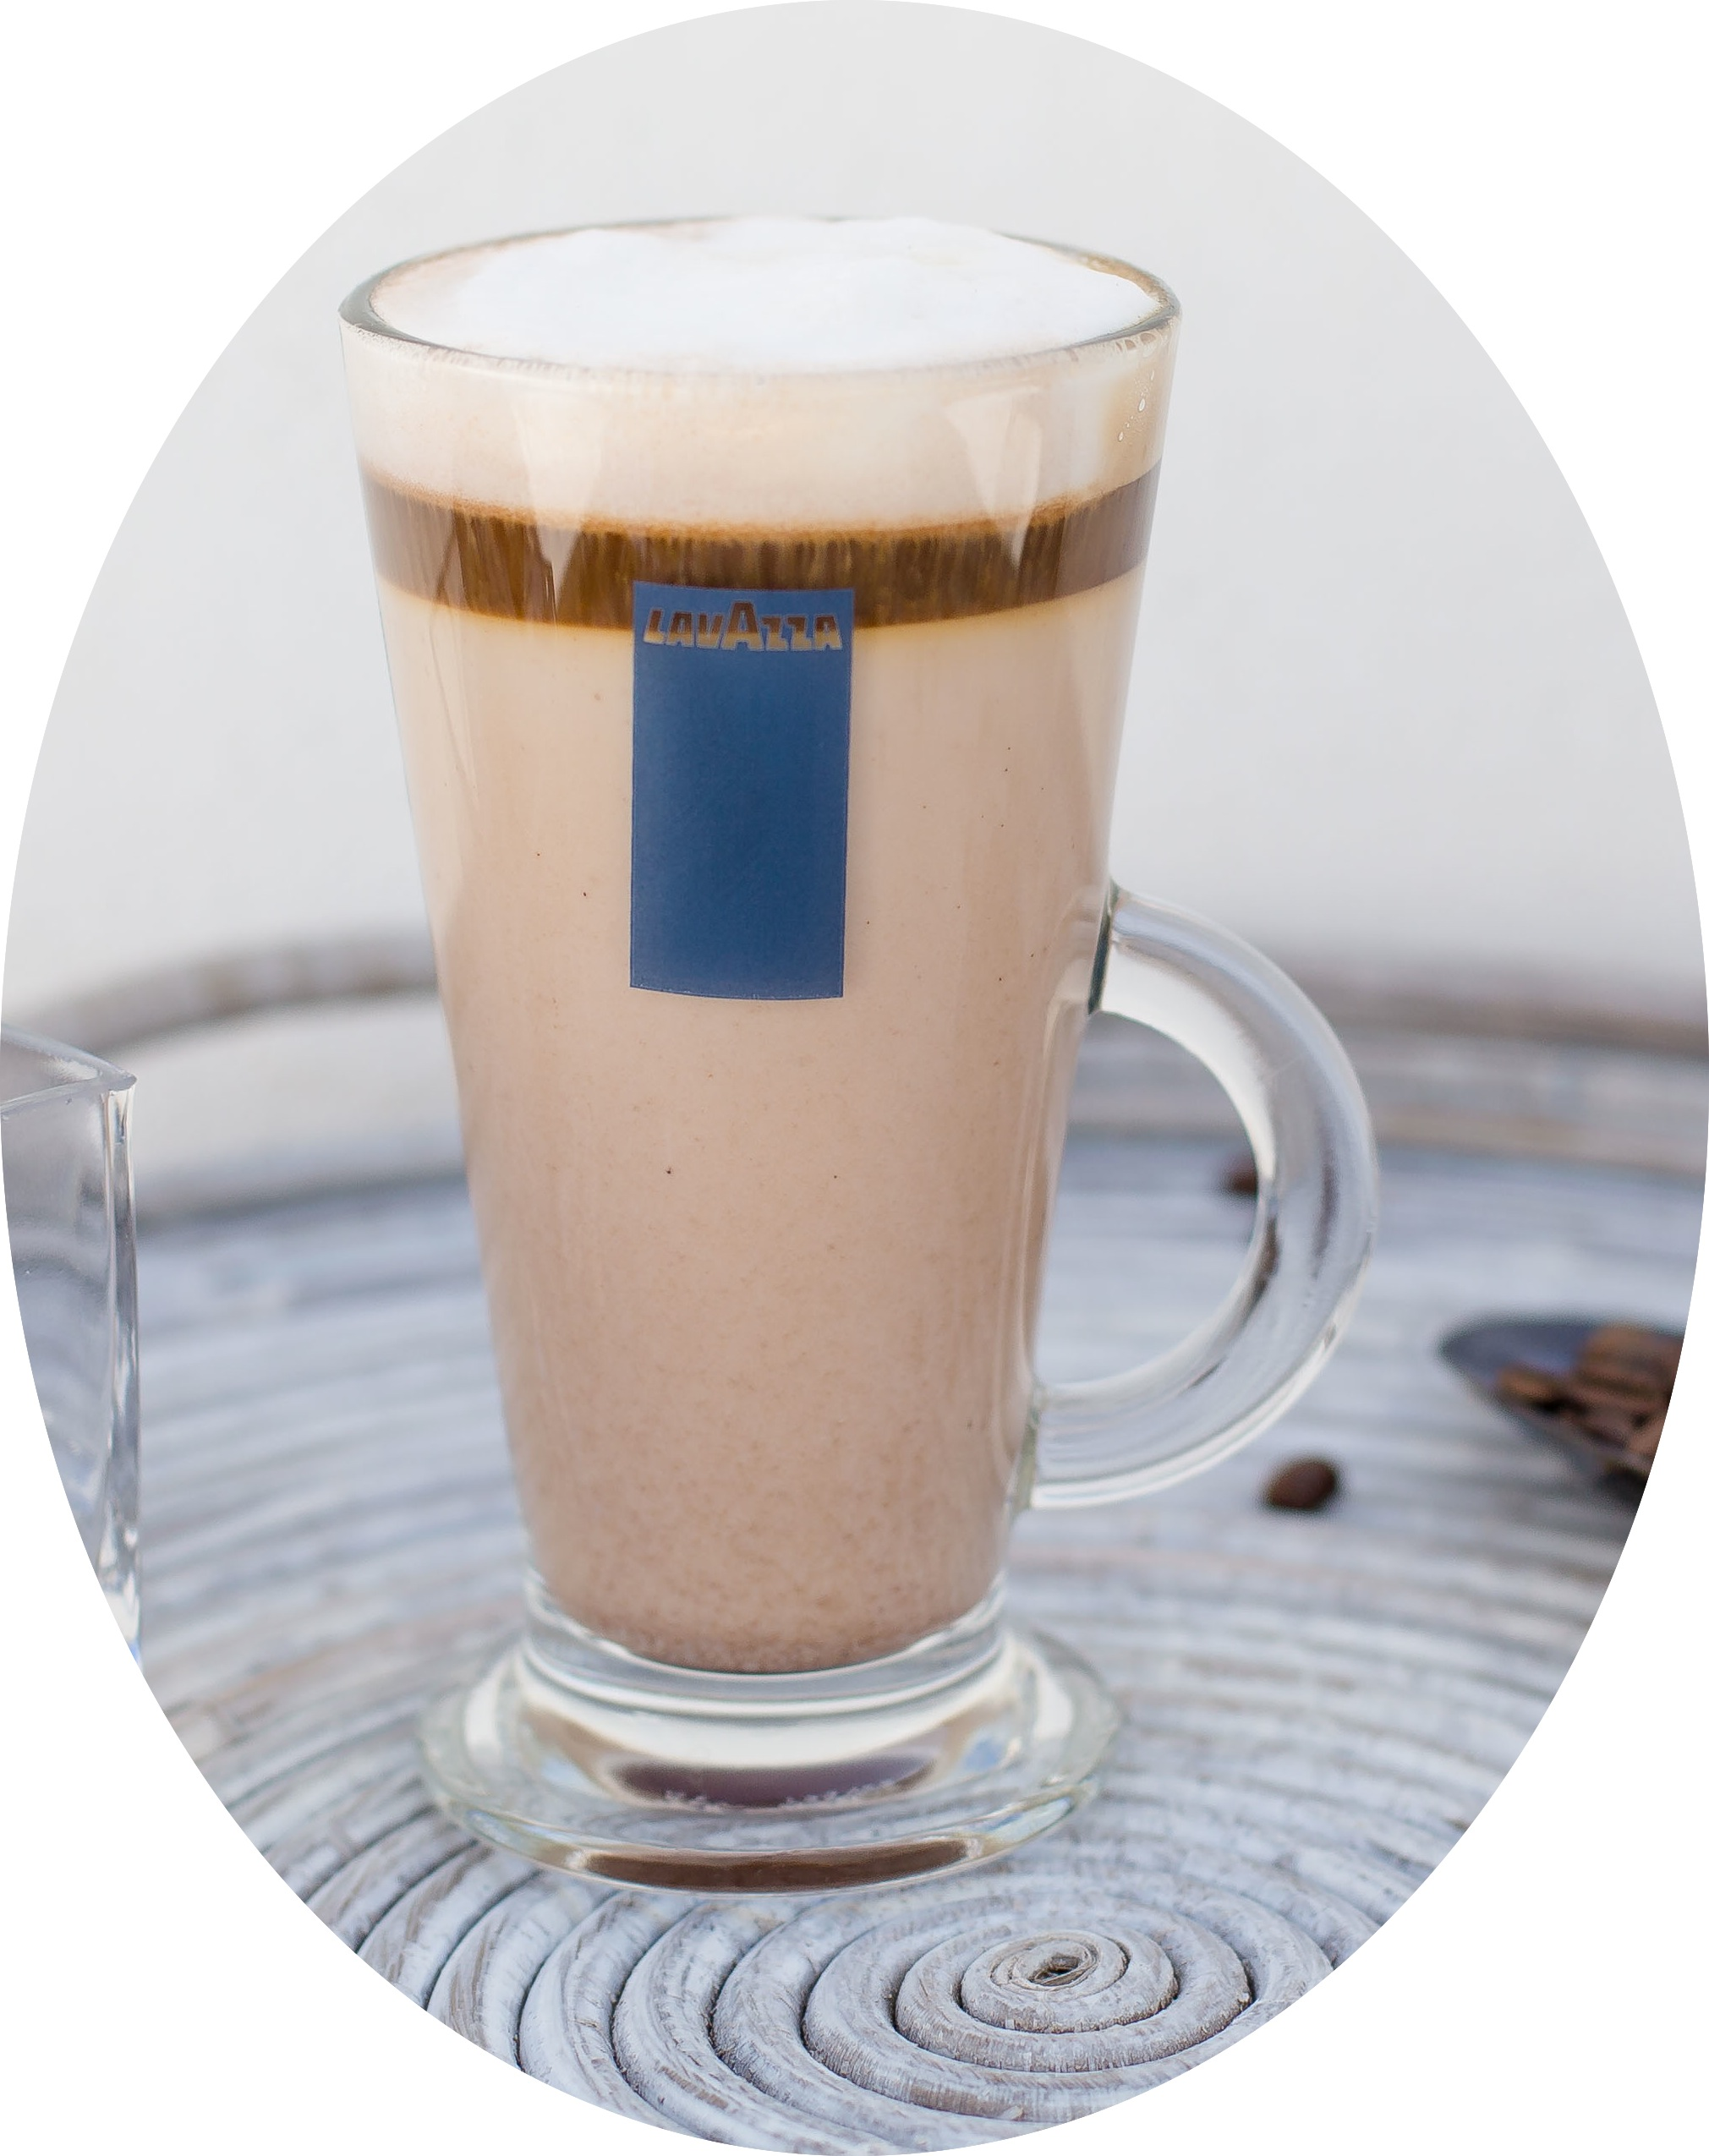___________________________________________________________________________________________________________________________________________________________________________________
BREAKFAST SANDWICHES ESPRESSO BAR

TIMELESS TREAT Cheese & Tomato R25 Espresso R15
2 rashers of bacon, 2 eggs, Cheese Griller, R60 Ham, Cheese & Tomato R30 Macchiato R20
2 tomato, chips & 2 toast Bacon, Egg, Cheese & Tomato R45 Americano R20
Chicken Mayonnaise R30 Cappuccino R20
PMS (Perfect Morning Surprise) R40 Red Cappuccino R20
2 rashers of bacon, 2 eggs, tomato, chips FROM THE KITCHEN Latte R25
& slice of toast Chai Latte R25
HAKE Chips & Salad R65 Mocha R25
HEALTHY & LIGHT R45 Hot Chocolate R20
Muesli, yoghurt with fresh fruit & honey SNOEK in traditional west R65 Milo R20
coast style with sweet potato
FRENCH TOAST R45 TEAS
2 slices with maple syrup, fried banana MUSSELS in garlic sauce R48 Rooibos, Five Roses, Green R15
and 2 rashers of bacon
SEAFOOD BASKET R105 MILKSHAKES (Double Thick) R30
BREAKFAST SMOOTHIE R38 Fish, Calamari, Squid & Prawns Vanilla, Strawberry, Banana
Mixed Berry or Mango & Banana yoghurt Chocolate, Peanut Butter, Milo
CALAMARI strips with dip R60 or Lime
OMELETES R25 chips & salad
2 egg omelets with cheese SOFT DRINKS
CHICKEN Schnitzel served with Soda Float (Coke/Cream soda) R20
Extra’s mushroom sauce, chips & salad R70 330ml Soda R12
Cheese, Mushroom, Bacon R10 500ml Still or Sparkling Water R15
Tomato or egg R 8 CHICKEN Wings with dip & chips R60 BOS iced tea R20
Cheese Griller R15
RUMP Steak – 200g served with R75 FRUIT JUICES 100% pure R18
Eggs & chips
SWEET TREATS
GREEK Salad with feta & olives R38 Waffle & Ice-cream R30
Scone, jam & cream or cheese R25
SEASONAL Salad with chicken R55 Cakes served with ice-cream R30
Fresh fruit & honey & mustard

HAWAIN Salad with chicken R45
& Pineapple

