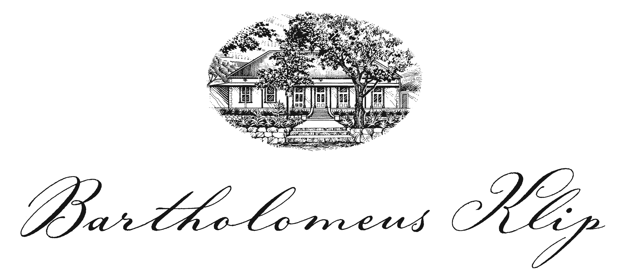

DINNER MENU

Ravioli:
Salted quail egg, home-made ricotta, marjoram butter, home grown vine tomato, parmesan

Springfield Life from Stone Sauvignon Blanc 2017 R200
By bottle only

*******
Mushroom Salad:
Wild forest Mushrooms, apricot chutney, Boland mountain cheese, caramelised pine nuts, brown butter, sauce

*******
Kabeljou:
Pan fried Eastern Cape farmed kabeljou, cauliflower puree, cauliflower chips, poached baby vegetables, vanilla jus, fish cracker

Fable Jackalbird 2013 R280
By bottle only

*******
Panna cotta:
Stewed rhubarb, buffalo yoghurt, double cream, pistachio ice cream, dried rose petals

Donkiesbaai Hooiwyn
By the glass R40

*******
Freshly brewed filter coffee
Selection of Ceylon and herbal tea

