Sides
Starches:
Buttered Mash Potato 22
Pan Fried Potato 22
House Fries 22
Mac ‘n Cheese 22
Veg:
Mixed roasted vegetables 22
Creamed Spinach 22
Side Salad 22
Cabbage and Radish Coleslaw 22

Salads
All salads served with in-house made ranch dressing
House Salad 50
Mixed lettuce, cherry tomatoes, julienne carrots, cucumber, spring onion and feta cheese.
Blue cheese, Pear and Bacon 70
Standard house salad topped with crispy bacon, crumbled blue cheese and poached pears.
Honey Mustard Chicken 70
Standard house salad topped with crumbed & fried chicken strips coated in honey mustard glaze and finished with sesame seeds.

Light Meals

Cheesy Jalapeno Cigars 60
Cream cheese & pickled jalapeno filling rolled in a thin layer of pastry & served with a sweet dipping sauce
Bacon, Camembert & Cranberry
Springrolls 70
Crispy bacon, camembert and cranberries wrapped in phyllo pastry and fried till golden, served with a ginger, honey and soy reduction.
Crumbed Chicken Wings 70
Marinated in buttermilk, crumbed and deep fried. Served with a dipping sauce of your choice. (Peri-peri, sweet chili soy or honey mustard)
Bacon Cherry Kebabs 65
Flame grilled and basted with our cherry bourbon sauce. Served on a bed of wild rocket.
Bacon Mushroom Poppers 60
Button mushrooms stuffed with feta, wrapped in bacon then crumbed and deep fried till crispy. Served with a tzatziki dipping sauce.
Wild Mushroom and Spinach Baguette 60
Toasted mini baguette stuffed with garlic and wilted spinach topped with melted cheddar and sautéed wild mushrooms.
‘Tater Skins 40
Hand-cut potato skins deep fried served with melted cheddar, crispy onion flakes and sour cream. Make it extra special by adding:
Crispy Bacon 22
Pickled Jalapeno’s 15

Killer Sandwiches
All served on a toasted tramezzini with wild rocket and a side of your choice

Philly Cheese Steak 85
Pan seared beef strips and sautéed green peppers & onions, finished with melted cheddar and a drizzle of smoky barbeque sauce.
Asian Pork 80
Pulled pork basted in our ginger-honey-soy reduction, topped with spring onion, radish and melted mozzarella.
Chicken, Feta and Peppadew 75
Grilled chicken strips topped with crumbled feta and Peppadews™ and finished with a drizzle of our in-house made coriander mayo.
Grilled Mac ’n Cheese 70
Rich and creamy macaroni cheese topped with extra mozzarella and cheddar and toasted to perfection. Any cheese lover’s dream!

Desserts

Sticky Toffee-Malva 40
Malva pudding twice baked in a sticky toffee sauce & served with whipped cream & a vanilla cinnamon custard.
Maple Bacon Ice-Cream 50
Homemade caramel ice-cream with sweet maple bacon bits served with salted pretzels & a cookie crumble.
Deconstructed Pavlova 45
Vanilla whipped cream, meringues mixed berry coulis, finished with a light custard & chocolate truffle.
Toasted Marshmallow Choc Brownie 50
Decadent chocolate brownie topped with toasted marshmallows and served with vanilla ice cream. (contains nuts)
Burgers
All served on a toasted sesame seed bun and with a side of your choice
The Blackmore Burger 85
200g in-house made pure beef patty served on a bed of lettuce with red pepper relish, cheddar cheese, coriander mayo and fried onions.
The Boerie Burger 90
A pinwheel of skinny boerewors served on a bed of wild rocket and spicy tomato relish topped with caramelized onions and sautéed wild mushrooms.
The Big Bad Wolf 95
Pork three ways: juicy pulled pork, bacon, pork crackling and crispy onion rings on a cabbage and radish slaw.
The Not-Mary’s Little Lamb 95
200g cumin spiced lamb patty served with cherry tomatoes, rocket, sautéed balsamic onions and fresh mint tzatziki.
The Roadrunner 85
Grilled chicken breast served on a bed of lettuce, topped with Peppadews™, coriander-mayo, cheddar cheese and crispy onion rings.
Tasmanian Devil 90
200g in-house made pure beef patty served on a bed of mixed lettuce, topped with creamy cheddar-jalapeno topping, crispy onion rings and chili spheres.
The Pappa Smurf 95
200g in-house made pure beef patty served on a bed of wild rocket, topped with crispy bacon and creamy blue cheese and crispy onion rings.
The Red Riding Hood 95
200g in-house made pure beef patty served on a bed of wild rocket, topped with cranberry compote and deep fried camembert cheese.

Specialities
Upsize your meal by adding an
extra side.
Mac ‘n Cheese 65
An extra creamy good old fashioned mac ‘n cheese served with a parmesan cheddar crisp. Make it extra special by adding:
Crispy Bacon 22
Pickled Jalapeno’s 15
Seafood Hushpuppies 90
Six crab, shrimp, hake and potato balls, deep fried and served with a garlic lemon butter dipping sauce and a side of your choice.
Chicken Supreme 95
Crumbed & fried chicken breast topped with a creamy mushroom sauce and melted cheddar cheese and served with a side of your choice.
Pork Belly 110
Slow cooked pork belly glazed with a ginger honey-soy reduction & topped with crispy pork crackling. Served with a side of your choice.
Braised Beef 100
Beef braised ‘till tender in an iron skillet with a hearty beef reduction & garnished with fresh micro herbs. Served with a side of your choice.
Beef Trinchado 95
Seared beef strips prepared in a creamy tomato based sauce, served mild or spicy with a side of toasted tramezzini.

Flame Grill
Served with a starch and veg of your choice
200g Fillet 130
250g Sirloin 115
300g Rump 125
700g Caveman Steak 160
500g T-Bone 140
450g Tomahawk 175
400g Cherry Bourbon Basted Pork Ribs 130
800g Cherry Bourbon Basted Pork Ribs 175
800g Beef Short Rib 170

Steak Toppings:
Deep Fried Camembert & Cranberry 25
Cheddar, Cream Cheese & Jalapeno 25
Creamy Blue Cheese & Pear 25
Creamy Feta and Peppadew™ 25

Sauces:
Parmesan & Cheddar 20
Mixed Peppercorn 20
Honey-Ginger-Soy 20
Blue Cheese 20
Dragon Sauce (Hot) 20

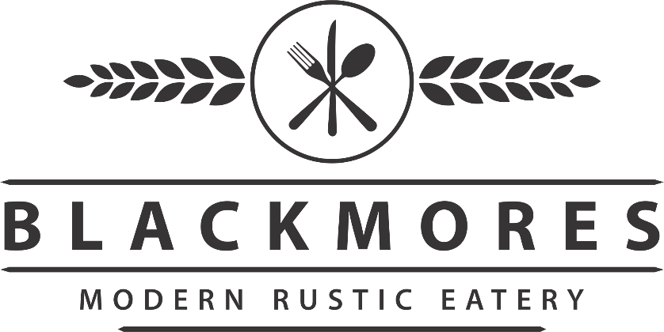

Wine list & Craft Beers
MCC’s & White Wines
Pongracz Brut 265
Pongracz Brut Rose 285
Durbanville Hills Sauvignon Blanc 120
Brampton Sauvignon Blanc 130
Graham Beck Waterside Chardonnay 105
Du Toitskloof Tunnel Dry White 90
(Per glass) 30
Du Toitskloof Tunnel Rose 90
(Per glass) 30

Red Wines
Jacobsdal Cabernet Sauvignon 225
Allesverloren Cabernet Sauvignon 245
Zonnebloem Shiraz 165
Diemersdal Merlot 199
Brampton Pinotage 150
Kanonkop Kadette Cape Blend 190
Du Toitskloof Tunnel Dry Red 100
(Per Glass) 35
Craft Beers
Rusty Trigger Lager (On tap) 35
Nine Inch Ale (On tap) 35
Jack Black Atlantic Weis (On tap) 40
Jack Black Butcher Block 42
Jack Black Lumberjack 42
Fiery Dragon Ginger Beer 32
Stellenbrau Lager 32
Stellenbrau Weiss 35
Devils Peak Lager 30
Devils Peak First Light 35

