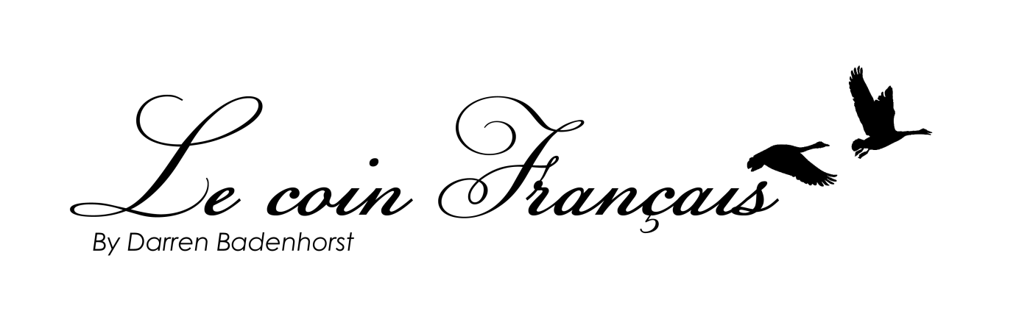

Tasting menu R845/R1295 with wine pairing
Chefs journey menu R1045/R1495 with wine pairing
Non-alcoholic pairing R325
Add cheese course R225

Menu
Amuse-bouche
3 hour cured and 1 hour cold smoked sustainable local trout, Franschhoek valley herb emulsion, organic Leeu Estate spring greens, toasted wild yeast and fennel pollen

Glenwood Unwooded Chardonnay
Or
8 hour braised Springbok shank, cold smoked and aerated pomme purée, dehydrated Franschhoek mushroom dust, ponzu marinated shiitake mushrooms
La Couronne Malbec
Chefs taster
Butter​ ​poached​ ​and​ ​BBQ​ ​north​ ​coast​ ​langoustine, ​aerated​ ​Gruberg ​and​ ​west​ ​coast​ ​snoek​ ​brandad​ ​velouté, wild​ ​vineyard​ ​​shoots, ​ ​garden​ ​pea​ ​and​ ​Le chêne pancetta ​risotto​
Elevation Vineyards Trig Beacon Pinot Noir
Or
Roast cauliflower and Boerenkaas tortellini, smoked pork emulsion, foraged local porcini, injected free range hens yolk, puffed pork
La Ferme Chantelle Brut 2014

Palate cleanser
6 hour confit local duck, cauliflower and vanilla purée, fynbos pickled onion, chesnut creme, spiced jus gras, Le chêne valley verde
Kloof Street Rogue
Or
Marble sous vide sustainable sea bass, squid, limoncello cured fennel and asparagus, fuchi emulsion, river herb split buttermilk
Normandie Karen Rosé

Pre-dessert
“Franschhoek forest floor” Almond cremeaux, spiced poached pear, smoked salted pear caramel,
olive oil semi-freddo
Medium Cream Sherry
Or
70% chocolate fondant sphere, cannelle infused “boudoirs parfait”, salted speculoos caramel, hazelnut and cocoa tuille silhouette
Boekenhoutskloof noble late harvest

Thank you for joining us at Le coin Français, we truly enjoyed hosting you and thank you for your support.
All the best from Chef Darren and the entire team,

A discretionary service charge of 12.5% is added to all bills, please feel free to add more if the experience exceeded your expectations.

