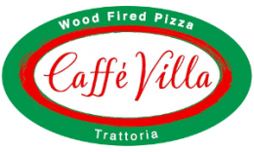

Café villa trattoria

haenertsburg

Open
Monday – Tuesday 11:00 – 19:00
Wednesday - Saturday 11:00 – 20:00
Sunday 09:00 – 20:00

087 086 1228

Delivery
@ r50.00
Orders must be r200 or more

Monday – Sunday

11:00 – 18:00

ALL OUR PIZZAS ARE MADE BY HAND, AND BAKED IN OUR WOOD BURNING OVEN.

- Jump the queue focaccia
-Garlic or Herb. R45.00
-Garlic and Herb. R45.00
-Garlic and Mozzarella. R60.00

- Margarita (V) R65.00
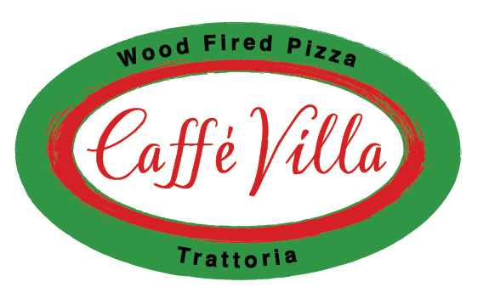
Plain and Simple.

- Browns Oinking Hot - Bacon, Tomato, Camembert Cheese
and Fresh Rocket. The Hot secret is in the sauce. (H) R120.00
A House original.

- Spicy chicken - Peppadews, Chicken strips and Olives. (M) R90.00
The hot chick in town.

- Regina - Ham and Mushrooms. R80.00
It is a pizza. Not the name of the waitress.

- Hawaiian - Ham and Pineapple. R80.00
Dress Code - Grass skirt and coconuts.

- Frutti Di Mare - Seafood Mix. R95.00
Finding Nemo and Dory not included.

- TRE FormagGio - Mozzarella, Feta and Camembert Cheese. (V) R100.00
Your Cardiologists nightmare.

- Quattro Stagioni - Ham, Mushroom, Olives and Artichokes. R120.00
The Village... Experience 4 seasons in one day.

- DiavolO - Bolognese, Green Pepper, Onions and Chilli. (H) R85.00
For a bit of fire in your belly.

- Delizioso - Fillet Strips, Bacon, Feta, Peppers and Onions. R130.00
A vegetarians nightmare.

- Bacon and Avo (when in season) R90.00
Another Caffe Villa favourite.

- popEYE - Spinach, Feta and Olives. (V) R90.00
No breaking of pizza boards after eating, please.

- Vegetarian Pizza-Fresh Tomato, Peppers, Onions,
Olives, Mushrooms . R90.00
A meat lovers nightmare.
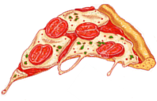
V- Vegetarian. M- Medium heat. H- Hot.

For Extra Yumminess

- Peppers, Pineapple, Garlic, Chilli and Onions. R10.00

- Mushrooms, Spinach, Olives, Cheddar and Peppadews. R15.00

- Mozzarella, Feta, Camembert, Ham, Bacon and Chicken Strips. R20.00

- Beef Strips, Seafood Mix, Bolognese, Artichokes, Anchovies, R25.00
Capers and Avocado (when in Season)

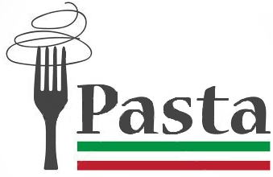

Our Fettuccine is made in house.

*PASTAS COME WITH A CHOICE OF PENNE OR FETTUCCINE.*

- Lasagne R75.00
Homemade pasta sheets, layered with Béchamel and Bolognese sauce
topped with Mozzarella cheese and then baked in our wood burning oven with fresh cream.

- Pescatore R90.00
A Seafood mix in a tomato or cream sauce.

- Alfredo R80.00
A delicious creamy sauce with ham and mushrooms.

- Filleto R90.00
A mouth-watering combination of fillet strips, mixed peppers,
onions and mushrooms in a tomato or cream sauce.

- Neapolitana (V) R85.00
A delightfully simple, yet delicious tomato based sauce
with onions and mushroom.

- Arrabbiata (M) R90.00
A mouth-warming tomato and chilli sauce with bacon and mushroom.

- Bolognese R80.00
Our secret Bolognese sauce will leave you wanting for more.

- CHICKEN FETTUCINI (M) R90.00
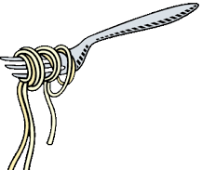
With lemon grass, spring onion, cream and chives.
V- Vegetarian. M- Medium heat. H- Hot.
Something to get you started.

- BEEF Carpaccio R90.00
Thinly sliced beef fillet, marinated in olive oil and basil,
Served with capers, shaving of parmesan and fresh rocket.
(We recommend adding coarse salt and black pepper.)

- BEEF BURGER & CHIPS R60.00

- BEEF BURGER, CHEESE & CHIPS R68.00

- PREGO & CHIPS R65.00

- Snails undercover OR OUT IN THE OPEN R65.00
Snails in a creamy white wine and garlic sauce
Served in a freshly baked pita bread or pita bread on the side.

- Chicken Livers peri-peri R55.00
Free-range chicken livers in a creamy peri-peri sauce,
served alongside a freshly baked pita bread.

- SPINACH & Mozzarella Mushroom R60.00
Fresh Brown mushrooms cooked in garlic butter,
topped with creamed spinach and melted mozzarella.
Baked in our wood burning oven.

- Cream of Tomato Soup R35.00
Based from homemade Napolitano sauce, with
lashings of fresh cream.
Served with pita bread on the side.

- cream of Potato Soup R35.00
Belly warming and creamy.
Served with pita bread on the side.

Gooda Food Like Mamma Makes!

*ALL THE SECONDOS EXCEPT SCHWARMAS ARE SERVED WITH SEASONAL VEG AND A SIDE OF YOUR CHOICE.*
*STEAKS COOKED OVER MEDIUM WILL BE DRIER AND WILL SHRINK!* *WE RECOMMEND - M-MR-R OPTIONS.*

- Pan Fried Brandy Pepper steak
Rump or fillet pan-Fried in a creamy black pepper sauce.
- 200g Fillet R140.00
- 300g Rump R140.00

- Flame-Grilled Steak
Rump or Fillet flame-grilled with our own special seasoning.
- 200g Fillet R130.00
- 300g Rump R130.00

- Ribs R175.00
600g Pork/Beef

- Rump SOSATIES ½ portion R80.00 R125.00 served in a spicy Portuguese sauce with fresh roll and chips

- POLLO AL FORNO (M) R120.00
Prepared to order in our wood burning oven
*TAKES 30-40 MINUTES* (Spicy but not Hot)
Please ask your server should you want it hot.

- SCHWARMA
Renowned in Limpopo!
Pan-Fried Beef or Chicken strips.
Served in a folded homemade Pita bread with crispy lettuce and a traditional pepper sauce.
- Beef ½ portion R80.00 R120.00
- Chicken ½ portion R80.00 R120.00

- TRINCHADA (M) R120.00
200g Beef fillet, sliced and served in a spicy Portuguese
sauce with fresh roll and chips.
Please ask your server should you want it hot.

- Lamb shanks (M) R145.00
±500g served with fresh roll and chips.

Please ask your server should you want to change the sauce.
Available Sauces @R15:
- Creamy Garlic.
- Cheese.
- Mushroom.
Available SIDES:
- Potato Wedges.
- Baked Potato with Sour Cream.
- Side Salad.
- Onion Rings.
- Creamed Spinach.

*EXTRA SIDES @R15*
- Pepper.
- Peri-Peri.

V- Vegetarian. M- Medium heat. H- Hot.

To Keep the Mini-Chefs going.
*ONLY FOR CHILDREN UNDER THE AGE OF 12 YEARS OLD*

- Kiddies Pizza R40.00
Topped with Mozzarella Cheese,
and your choice of two toppings:
Ham or chicken strips and Mushrooms or Pineapple.

- KIDDIES FISH R35.00
Battered Hake Fillet.
Served with Potato Wedges.

- Kiddies Schnitzel R35.00
Crumbed Chicken breast.
Served with cheese sauce and potato wedges.

- Kiddies BOLOGNESE R40.00
Traditional ground beef in tomato-based
sauce served on a bed of either penne or fettuccine.

For all the Health bugs.

- Greek Salad
South African Style. Mixed Greens, Chunky Tomatoes, Onions, Green Pepper, Cucumber, Olives and Feta Cheese.
Homemade mayonnaise vinaigrette on the side.
- Half (1-2 People) R45.00
- Full Portion (3-4 People) R80.00
- Caprese Salad
Layers of Mozzarella and Tomato drizzled
with a homemade Olive Oil and Basil marinade.
- Side Portion R45.00
- As a Light Meal R85.00
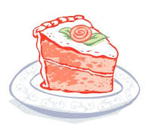

To end a perfect evening and satisfy your sweet-tooth.

- Tiramisu R35.00
Made the authentic Italian way with Mascarpone Cheese
and liqueur.
Presented as a slice of cake.

- Crème brûlée R25.00
Sweet dessert made of a smooth, thick custard
covered with a hard top of cooked sugar.

- CHEESECAKE R35.00
Fridge styled cheesecake (Ask your Server for flavour)

- Carrot CAKE R35.00
Freshly baked to perfection

- MALVA PUDDING R35.00
Served with custard or ice cream

- Ice cream & chocolate sauce R35.00
Good old fashioned delight

Available till 12h00.

- Fluffy 3 egg omelette R65.00
with choice of Ham / Salami / Bacon
with choice of Mixed Peppers, Pepperdews or Mushrooms

- Braai broodjie R45.00
with choice of Ham / Salami / Bacon
with choice of Mushrooms, Mixed Peppers, Onion or Pepperdews

- French toast R45.00
with choice of Maple syrup or Bovril
served with Fresh Crispy Garden Salad Garnish
and 3 Rashers of Bacon

- anchovy toast R45.00
served with Fresh Crispy Garden Salad

